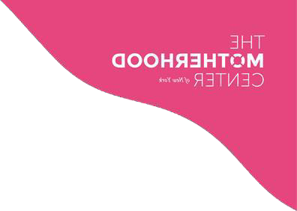

COVID Guidelines

All patients who opt in to in-person treatment at The Motherhood Center must abide by the following COVID safety protocols:

General:
- We request vaccination status before patients begin in-person treatment.
- All patients must take a weekly COVID test before arriving on-site. Send a dated photo of a self-administered negative test preferably the night before no later than the morning you are expected on-site to dayprogram@themotherhoodcenter.com. If we do not receive your test result before you arrive onsite you will need to take a self-administered rapid test in our elevator lobby restroom before entering the office. We can provide you with tests to take home.
- Everyone above the age of two must be masked at all times, unless they are in a room alone or are eating. The Motherhood Center has disposable masks available as needed.
- Patients who are experiencing cold-like symptoms including fever, persistent cough, or sore throat, should stay at home and will have the option to join virtually. Patients should provide as much notice as possible if they will be out sick.
- If a patient travels, they need to speak with their treatment team to determine whether or not they need to provide a negative test before returning to the center in person.
- If a patient is exposed to COVID, they must provide a negative test before returning in person.
- If a patient tests positive, they must quarantine for at least 6 days from the onset of symptoms, be asymptomatic for at least 24 hours, and provide a negative test before returning to the office.
- Patients are asked not to loiter in the hallways, reception area, or bathroom hallway.

Arrival Procedure:
- Prior to arrival on-site, patients must fill out a covid screener.
- Every Monday or day you are expected on-site, patients must send Dayprogram@themotherhoodcenter.com a dated photo of a self-administered negative Covid test taken the night before no later than the morning of. No entry to the office will be allowed without a negative test on file.

Guest Policy:
- Patients may have one person accompany them to the office on day one and staff must be notified in advance.
- After day one, unless a clinician recommends a guest accompany a patient, all guests must remain outside of the building for drop off and pick up.
- If an on-site family session is scheduled, the partner or family member must complete the COVID screener and take a rapid test in our elevator lobby before entering the office. Once the family session has finished, the partner or family member must leave the office.
- These policies do not apply to infants who are staying in The Motherhood Center nursery.

Kitchen:
- The refrigerator is available for personal food storage.
- We recommend bringing a reusable coffee mug and/or water bottle but will provide disposable cups if needed.
- Please do not bring in any food or drink to share.
- Coffee, tea, water, individually wrapped snacks, and lunch with disposable utensils are provided by The Motherhood Center.

Nursery:
- The Motherhood Center supplies diapers, wipes, and swaddles, but you are welcome to bring your own supplies as well. The swaddles are washed daily and not shared amongst babies.
- All bassinets are assigned to babies on day one of the parent’s admission
and not shared.
- All rockers are sanitized between uses.
- All toys are disinfected daily and not shared between babies during the day.
- A dedicated pumping room will be wiped down between uses.
- If your baby is exposed to COVID, they will need to quarantine for 5 days and provide a negative test before returning to the office.

